TEST CASES
TRACK 1
- Rev of Overdue Opportunities

Filters used:
Calendar[Date] -> 2026-08
DIM GEO [Level 3 region] -> BENELUX,CH
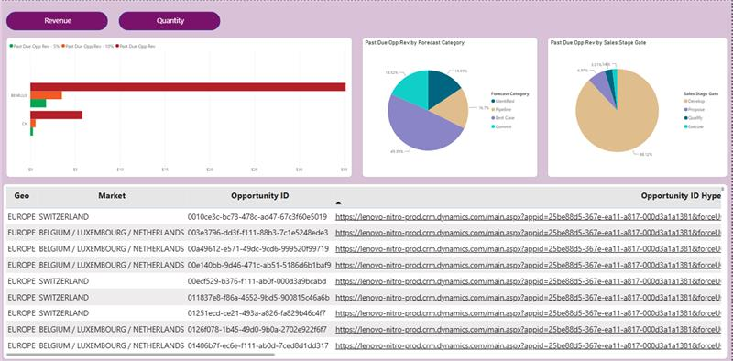

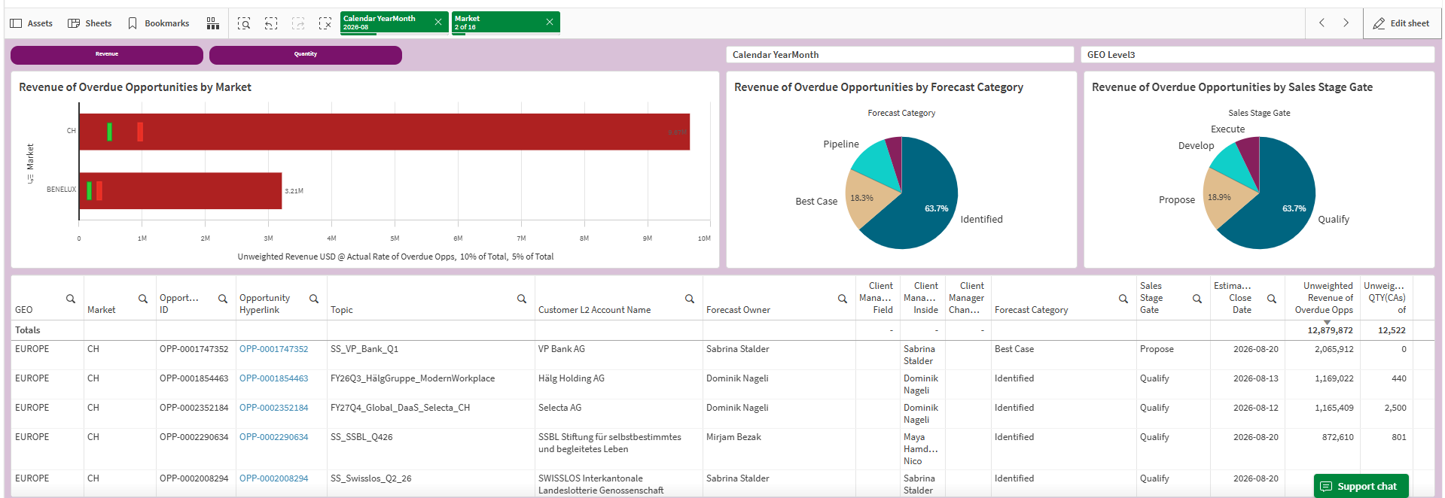
- Rev of 7 Days Opportunities

Filters used:
Calendar[Date] -> 2026-09
DIM GEO [Level 3 region] -> CZ/SK,EECA
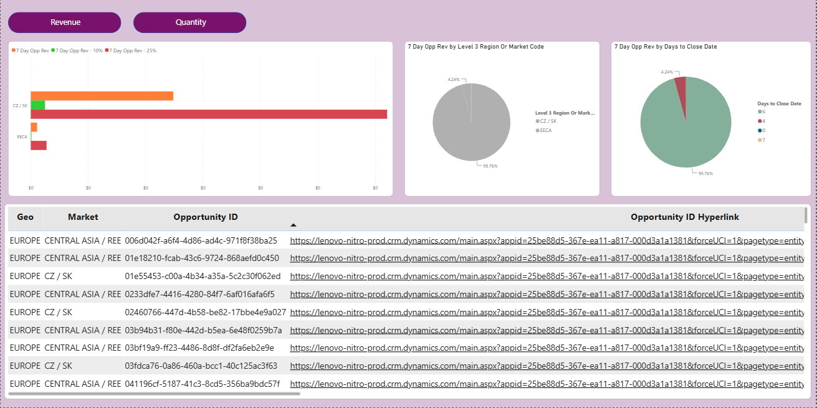

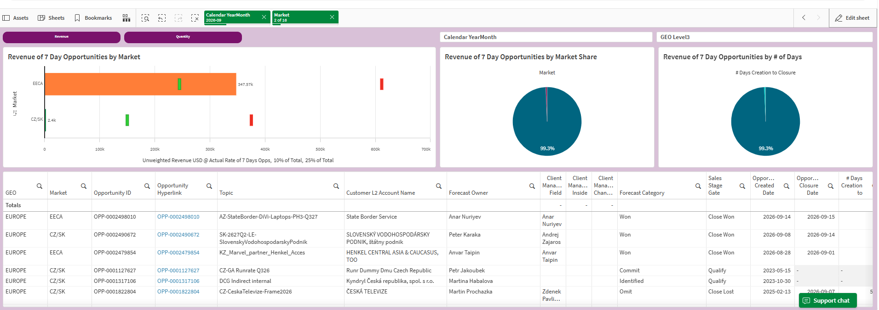

3) Rev of Missing PN Opportunities
Filters used:
Calendar[Date] -> 2026-09
DIM GEO [Level 3 region] ->FRANCE,GAT
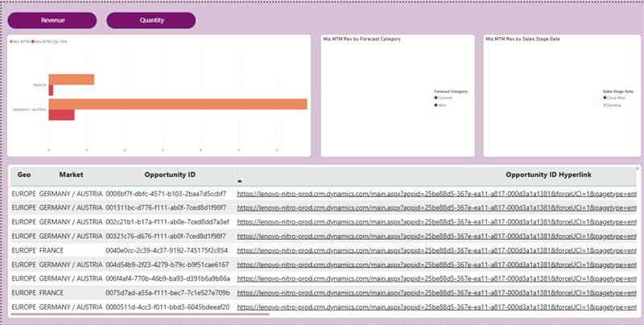

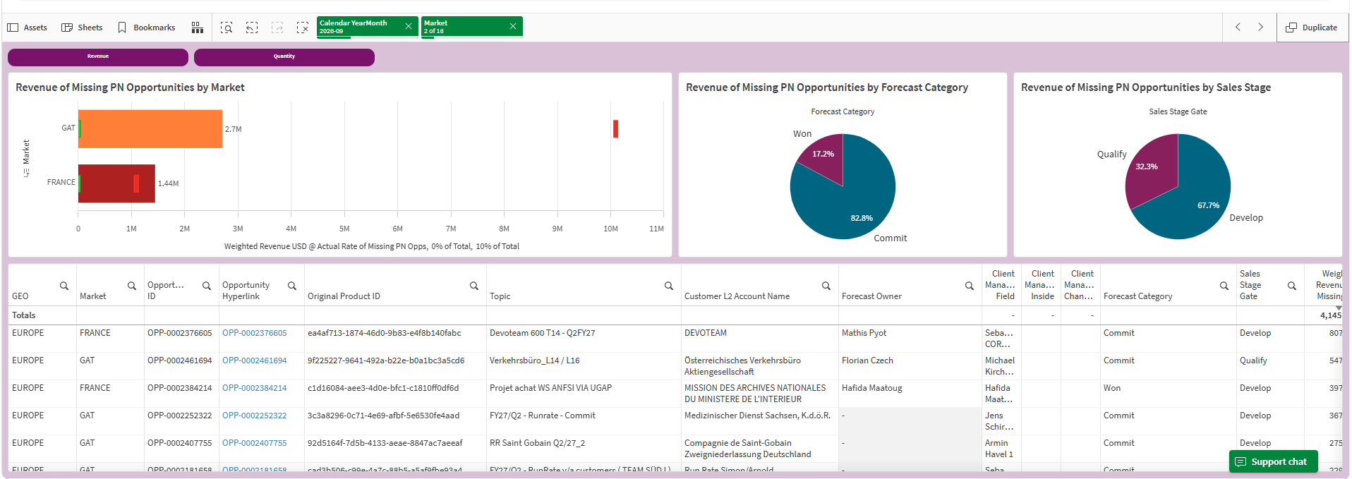

TRACK 2

- Rev of Overdue Opportunities
Filters used:
Calendar[YearMonth]-> 2026-08
Country[GEO Level3] -> BENELUX,CH
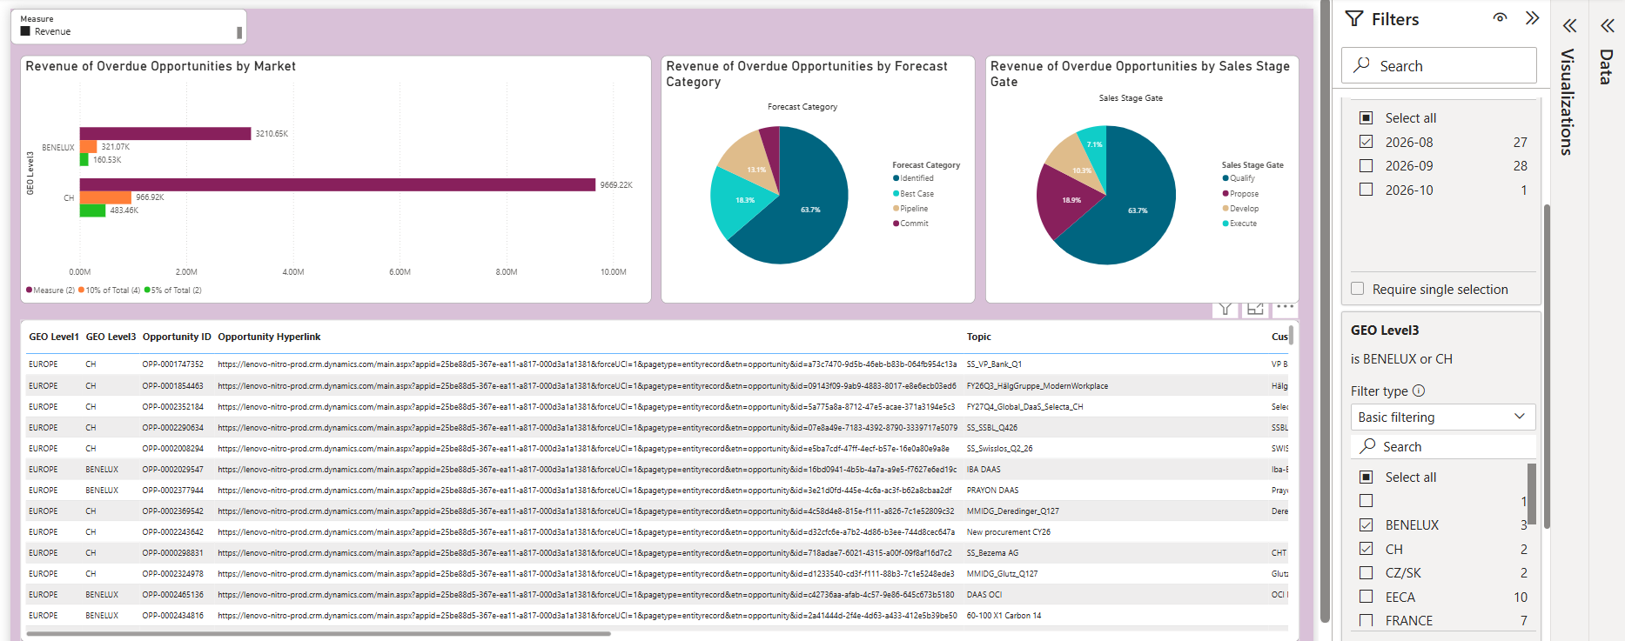

- Rev of 7 Days Opportunities

Filters used:
Calendar[YearMonth]-> 2026-09
Country[GEO Level3] -> EECA,CZ/SK

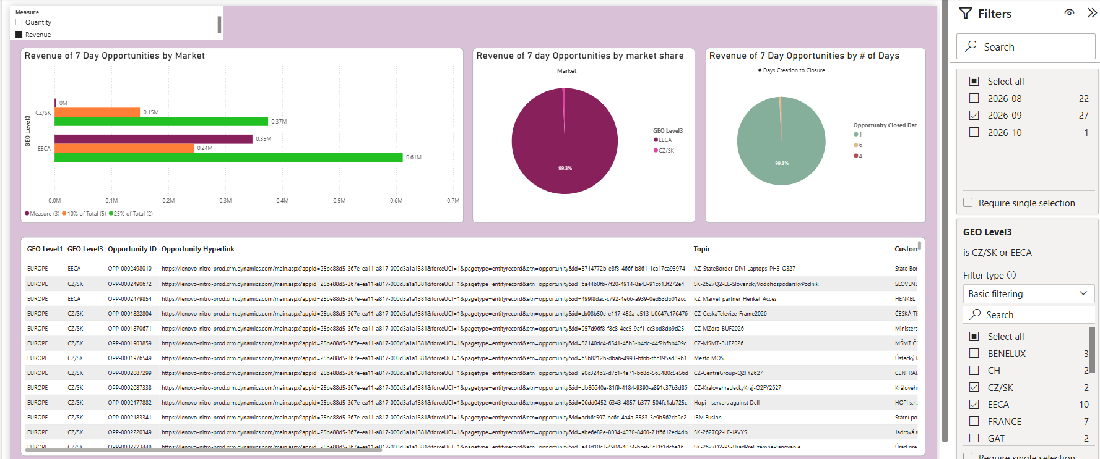

- Rev of Missing PN Opportunities

Filters used:
Calendar[YearMonth]-> 2026-09
Country[GEO Level3] -> FRANCE,GAT

